***Exploring Insights from Synthetic Airline Data Analysis with Qlik***



***1.INTRODUCTION***

***1.1 OVERVIEW : A BRIEF DESCRIPTION ABOUT YOUR PROJECT.***

The project **"Exploring Insights from Synthetic Airline Data Analysis with Qlik"** involves utilizing synthetic airline data to derive valuable insights using Qlik, a business intelligence and data visualization tool.This project details of airline data to uncover valuable insights that can significantly improve the airline sector's efficiency and performance. At its core, the project aims to address the prevalent issues of flight delays and cancellations, which not only disrupt passengers travel plans but also lead to substantial operational inefficiencies.

**Scenario 1: Enhancing Operational Efficiency**

Operational efficiency is crucial for the profitability and sustainability of airlines. By analyzing data on flight routes and maintenance schedules, airlines can identify areas where resources are being underutilized or overextended. Additionally, predictive maintenance algorithms can be developed from historical maintenance data to anticipate and address potential aircraft issues before they lead to delays or cancellations. By optimizing these operational aspects, airlines can reduce costs, enhance resource allocation, and improve overall efficiency.

**Scenario 2: Improving Customer Satisfaction**

Customer satisfaction is directly linked to the reliability and convenience of flight services. By studying passenger feedback, flight punctuality, airlines can pinpoint specific pain points affecting the customer experience. For instance, data analysis might show that delays are frequently caused by inefficient boarding processes or prolonged baggage claim times. Additionally, offering real-time updates and personalized communication to passengers during disruptions can significantly enhance the travel experience. These efforts to address customer concerns and improve service reliability will lead to higher satisfaction levels.

***1.2 PURPOSE : THE USE OF THIS PROJECT. WHAT CAN BE ACHIEVED FROM THIS.***

The primary purpose of this project is to leverage a comprehensive airline dataset to develop actionable insights and strategies aimed at improving various aspects of airline operations. By optimizing flight routes and schedules, airlines can enhance their punctuality and reliability, thereby significantly improving the overall travel experience for passengers. Furthermore, these optimizations will contribute to better resource management and operational efficiency, reducing costs and enhancing profitability.The project aims to achieve the following:

1. **Minimize Delays and Cancellations:**
   * Identify patterns and causes of delays and cancellations.
2. **Improve On-Time Performance:**
   * Utilize data-driven insights to develop strategies for better punctuality.
   * Adjust operational procedures to ensure consistent on-time departures and arrivals.

Using the insights and strategies developed through this project, several significant achievements can be realized within the aviation industry:

1. **Improved Punctuality and Reliability:**
   * By optimizing flight schedules and operational procedures, airlines can achieve higher on-time performance, reducing delays and cancellations. This leads to a more reliable travel experience for passengers, enhancing overall satisfaction and loyalty.
2. **Increased Customer Satisfaction and Loyalty:**
   * By addressing points identified through customer feedback and improving the overall travel experience, airlines can significantly enhance customer satisfaction and loyalty. This includes smoother boarding processes, better communication during disruptions, and personalized services tailored to passenger preferences.

***1.3 TECHNICAL ARCHITECTURE***

To architect a technical framework for leveraging the airline dataset and fulfilling the project objectives, a systematic approach is essential. Firstly, we have to gather data which is given to us and extract the airline dataset , likely a cloud-based storage solution such as Qlik Cloud Analytics, ensuring both security and accessibility. Subsequently, ETL (Extract, Transform, Load) processes will clean, transform, and refine the raw dataset for analysis. Following this, analytical tools will be employed for exploratory data analysis, predictive analytics, and insights generation, empowering stakeholders to visualize patterns and trends using visualization platforms like Qlik Sense.We will perform different types of dashboard and StoryTelling .Further, Continuous monitoring, maintenance, and optimization will ensure the sustained efficency and reliability of the technical architecture, enabling the aviation industry to leverage data analytics for enhanced operational efficiency, improved customer satisfaction, and informed decision-making.

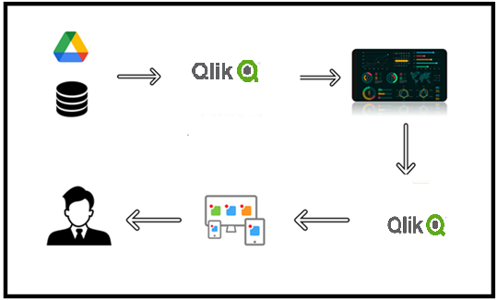

***2.DEFINE PROBLEM / PROBLEM UNDERSTANDING***

***2.1 SPECIFY THE BUSINESS PROBLEM***

The business problem addressed by this project is the need for comprehensive strategies to minimize flight delays, cancellations, and operational inefficiencies within the aviation industry. By analyzing the provided airline dataset, which includes passenger information, flight details, and customer satisfaction surveys, the project aims to identify patterns in delays, cancellations, and on-time performance. These insights will be used to develop strategies that optimize flight schedules, minimize disruptions, and enhance the overall travel experience for passengers.

Specifically, the project seeks to address the following challenges:

1. **Flight Delays and Cancellations:** The dataset contains information on flight status, including indicators for on-time performance, delays, and cancellations. By analyzing these data points, the project aims to identify the root causes of delays and cancellations, whether they are due to weather conditions, operational issues, or other factors.
2. **Operational Inefficiencies:** The dataset also includes details on airport locations, pilot names, and flight routes. Analyzing this information can reveal inefficiencies in flight scheduling, crew allocation, and route planning, which contribute to operational disruptions and customer dissatisfaction.
3. **Customer Satisfaction:** Customer satisfaction survey data provided in the dataset offers insights into passengers' experiences and perceptions. By correlating this feedback with flight performance metrics, the project aims to understand the impact of delays, cancellations, and other factors on customer satisfaction levels.
4. **Optimizing Flight Routes and Schedules:** Leveraging insights from the dataset, the project seeks to optimize flight routes, departure times, and frequencies to improve on-time performance and minimize disruptions.



***2.2 BUSINESS REQUIREMENTS***

To effectively utilize the airline dataset and address the project's objectives, several key business requirements need to be articulated. Firstly, the airline must establish robust data collection and integration mechanisms to gather comprehensive information encompassing passenger details, flight specifics, and customer satisfaction surveys. Ensuring the quality and consistency of this data through rigorous validation and cleaning processes is paramount to maintaining its integrity throughout the analysis. Following data collection, it is essential to identify patterns within the dataset related to flight delays, cancellations, and on-time performance. This involves analyzing factors contributing to disruptions, such as weather conditions, operational issues, and airport congestion. Additionally, predictive analytics and machine learning models must be developed to forecast potential delays and cancellations, enabling proactive measures to mitigate these disruptions.

The insights derived from the dataset should inform strategies to optimize flight schedules, routes, and resource allocation, thereby enhancing on-time performance and operational efficiency. Analyzing customer satisfaction survey data is crucial for understanding passenger experiences and identifying areas for improvement. These insights will guide targeted initiatives to enhance the overall travel experience and boost satisfaction levels. Furthermore, interactive dashboards and reports need to be created for visualizing the insights and providing stakeholders with actionable information to support decision-making and strategic planning.

Scalability and performance optimization of the analysis framework are essential to handle large volumes of data efficiently and deliver timely insights. Continuous monitoring, maintenance, and iteration of analysis methodologies and optimization strategies are necessary to adapt to evolving industry trends and ensure long-term success. By adhering to these business requirements, the project aims to significantly improve the functioning and efficiency of the aviation industry, minimize disruptions, and enhance the overall travel experience for passengers.

***2.3 LITERATURE SURVEY***

A literature survey for this project involves reviewing existing research and studies related to several key areas within the aviation industry. First, we need to explore literature on the factors influencing operational efficiency, such as route optimization, resource allocation, and flight scheduling practices. Studies on the causes of flight delays and cancellations, including weather, technical issues, and airport congestion, are crucial for understanding the root problems. Research on strategies to mitigate these delays and cancellations, such as predictive analytics and real-time monitoring systems, will provide insights into potential solutions.

Next, we should examine literature on enhancing on-time performance through improved scheduling, capacity management, and technological advancements. Understanding how other airlines and industries have successfully implemented these strategies can offer valuable lessons. Additionally, reviewing studies on customer satisfaction in the aviation industry will help us understand the impact of delays and cancellations on passenger experiences. This includes analyzing factors that influence customer satisfaction and loyalty, such as service quality, communication during disruptions, and overall travel experience.

Furthermore, exploring research on data analytics and machine learning techniques applicable to aviation will guide the development of predictive models and optimization strategies. Case studies and best practices from leading airlines and innovative startups will also provide practical examples of successful implementations. Finally, we must consider literature on data privacy and security to ensure compliance with regulations like GDPR and HIPAA when handling sensitive passenger information.

By conducting a comprehensive literature survey across these areas, the project can build on existing knowledge to develop effective strategies for minimizing delays, optimizing flight schedules, and enhancing the overall travel experience for passengers.

***3.DATA COLLECTION***

***3.1 COLLECT THE DATASET***

The airline dataset consists of various data's, each holding specific types of information that collectively provide a comprehensive view of the airline operations and passenger experience. Here's an explanation of each collected data's:

1. Passenger ID:
   * A unique identifier assigned to each passenger, used to distinguish between individual records in the dataset.
2. First Name:
   * The first name of the passenger, which helps in identifying individuals.
3. Last Name:
   * The last name of the passenger, used in combination with the first name for identification purposes.
4. Gender:
   * The gender of the passenger (e.g., Male, Female, Non-binary). This information can be used for demographic analysis.
5. Age:
   * The age of the passenger, which is useful for segmenting passengers into different age groups and analyzing age-related patterns.
6. Nationality:
   * The country of citizenship of the passenger. This can be used to understand the geographic distribution of the airline's customer base.
7. Airport Name:
   * The name of the airport from which the flight departs or arrives. This helps in identifying the origin and destination of flights.
8. Airport Country Code:
   * A standardized code representing the country of the airport. This is useful for international comparisons and analyses.
9. Country Name:
   * The full name of the country where the airport is located, providing additional context beyond the airport country code.
10. Airport Continent:
    * The continent where the airport is situated. This can help in regional analysis and understanding continental travel patterns.
11. Continents:
    * The continent data for analysis purposes, helping in regional segmentation and comparison.
12. Departure Date:
    * The date when the flight departs. This is essential for time-based analysis, including identifying peak travel periods and trends.
13. Arrival Airport:
    * The name of the airport where the flight is scheduled to arrive. This, along with the departure airport, helps in analyzing flight routes.
14. Pilot Name:
    * The name of the pilot operating the flight. This information can be used for operational analysis and to understand the impact of specific pilots on flight performance.
15. Flight Status:
    * The current status of the flight, such as scheduled, departed, arrived, delayed, or canceled. This is crucial for operational performance analysis.

***3.2 CONNECT DATA WITH QLIK SENSE***

To connect the airline dataset to Qlik Sense, we need to follow several steps to ensure seamless data integration and effective analysis. First, we need to prepare the dataset by ensuring it is clean, well-structured, and stored in a format compatible with Qlik Sense, such as CSV, Excel. We then import the dataset into Qlik Sense by navigating to the Data Manager within the Qlik Sense interface. Here, we can connect to various data sources, upload our dataset, and configure the connection settings.

Once the data is loaded, we should define relationships between different data fields to create a coherent data model. For example, we can link passenger information with flight details using fields like passenger ID and flight status. This step is crucial for ensuring that our analyses and visualizations are accurate and meaningful. We can also create calculated fields and transformations to enrich the dataset, such as grouping ages into age categories or converting date fields into weekday/weekend indicators.

After establishing the data model, we proceed to create interactive dashboards and visualizations. Qlik Sense offers a range of chart types and visualization tools to represent data insights effectively. We can create charts to visualize patterns in flight delays and cancellations, customer satisfaction levels, and on-time performance metrics. Using Qlik Sense's associative model, we can easily explore the data by making selections and seeing how different aspects of the dataset are connected.

To enhance the analysis, we can also use Qlik Sense's advanced analytics capabilities, such as integrating predictive models to forecast delays or cancellations. By applying filters and drill-down capabilities, we can gain deeper insights into specific areas, such as delays by airport or customer satisfaction trends over time.

Finally, we should set up regular data refresh schedules to ensure that the dashboards and analyses are always based on the latest data. Qlik Sense allows us to automate data reloads, ensuring our insights remain up-to-date. By following these steps, we can effectively connect the airline dataset to Qlik Sense and leverage its powerful data visualization and analysis tools to optimize flight schedules, enhance on-time performance, and improve overall operational efficiency within the aviation industry.

***4.DATA PREPARATION***

***4.1 PREPARE THE DATA FOR VISUALIZATION***

Data preparation is the process of cleaning, transforming, and organizing raw data into a usable format for analysis and visualization. It involves several steps, including data cleaning to remove duplicates and correct errors, data transformation to standardize formats and encode categorical variables, and data enrichment to add relevant context from external sources. Feature engineering may be performed to create new variables that provide additional insights, while data aggregation and sampling techniques are used to summarize and manage large datasets efficiently. The goal of data preparation is to ensure that the dataset is accurate, complete, and ready for analysis, enabling more reliable and meaningful insights. This step is crucial in any data-driven project as it directly impacts the quality and effectiveness of subsequent data analysis and visualization efforts.Since the data is already cleaned, we can move to visualization.

***Data Cleaning And Data Pre-Processed :***

[**https://p1bcpe3frd9q2dt.sg.qlikcloud.com/sense/app/31786386-fe20-4a7c-af83-4a941d96254f**](https://p1bcpe3frd9q2dt.sg.qlikcloud.com/sense/app/31786386-fe20-4a7c-af83-4a941d96254f)

***5. DATA VISUALIZATIONS***

Data visualization is the graphical representation of information and data, using visual elements like charts, graphs, and maps to make complex data more accessible and understandable. It helps identify trends, patterns, and outliers, enabling faster and more informed decision-making. Interactive tools allow users to engage with data dynamically, facilitating deeper insights and easier comparisons. In the airline industry, data visualization can track on-time performance, analyze flight delays and cancellations, optimize flight routes, and understand customer satisfaction. By transforming raw data into visual formats, airlines can enhance operational efficiency, improve passenger experience, and communicate insights effectively to stakeholders.

***5.1 VISUALIZATIONS***

**1.Trasported Passengers**

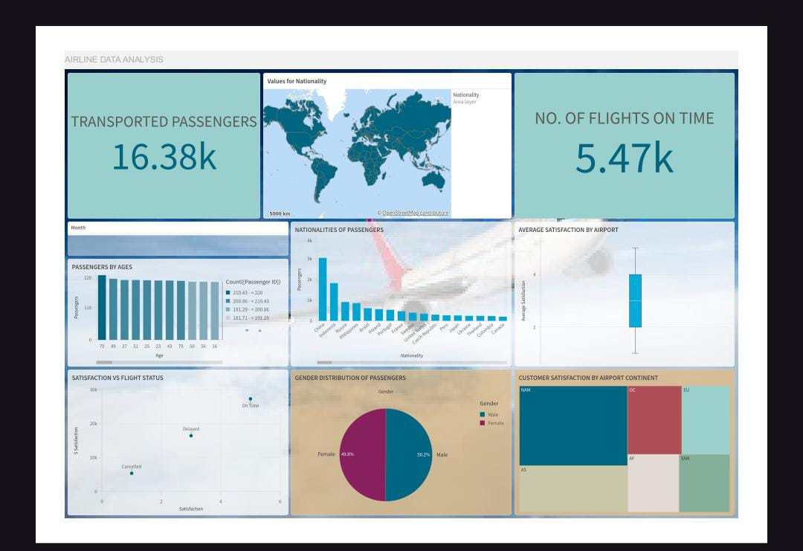

**2.NUMBER OF FLIGHTS ON - TIME**



**3.PASSENGERS BY AGES**



**4.AVERAGE SATISFACTION BY AIRPORT**

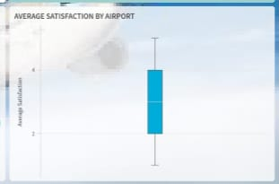

**5.SATISFACTION VS. FLIGHT STATUS**

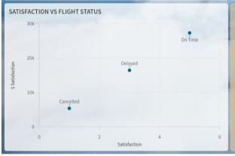

**6.GENDER DISTRIBUTION OF PASSENGERS**

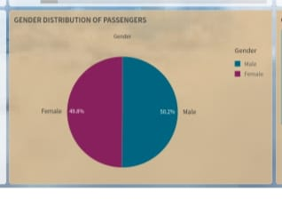

**7.CUSTOMER SATISFACTION BY AIRPORT CONTINENT**

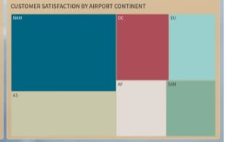

**8.VALUES FOR NATIONALITY**

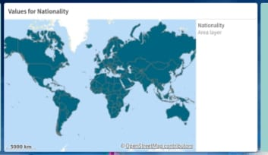

**9.FLIGHT STATUS DISTRIBUTION**

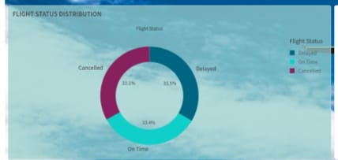

**10.NUMBER OF FLIGHTS BY AIRPORT**

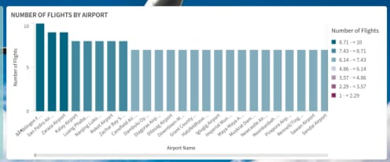

**11.MONTHLY TRENDS IN FLIGHT DELAYS AND CANCELLATIONS**

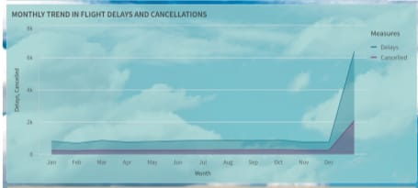

**12.CUSTOMER SATISFACTION OVER TIME**

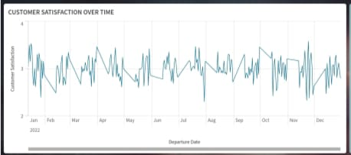

**13.AVERAGE AGE OF PASSENGERS OVER TIME**

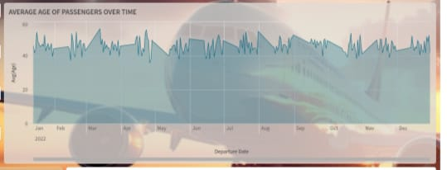

**14.MONTHS BY DAY TYPE**



***6. DASHBOARD***

In Qlik, a dashboard is an interactive and dynamic tool that allows users to visualize and analyze data from multiple sources in a cohesive and intuitive manner. Qlik dashboards are designed to provide a comprehensive view of key performance indicators (KPIs), metrics, and other relevant data points, enabling users to monitor and explore their business performance effectively.

Qlik's associative model allows users to make selections in any part of the dashboard and instantly see the effects across the entire dataset. This interactivity helps users uncover hidden insights and understand the relationships within their data. Dashboards in Qlik typically include various visual elements such as bar charts, line graphs, pie charts, tables, and maps, which are all customizable to suit specific analytical needs.

Key features of Qlik dashboards include:

1. **Interactivity:** Users can click on different elements within the dashboard to filter and drill down into more detailed data, making it easy to explore and analyze information.
2. **Real-Time Data Updates:** Qlik dashboards can be connected to live data sources, ensuring that the information displayed is always up-to-date.
3. **Customizability:** Dashboards can be tailored to meet specific business requirements, with options to customize layouts, colors, and visual elements.

**6.1 RESPONSIVE AND DESIGN OF DASHBOARD**

***DASHBOARD 1: AIRLINE DATA ANALYSIS***



***DASHBOARD 2 : FLIGHT STATUS AND OPERATIONS***

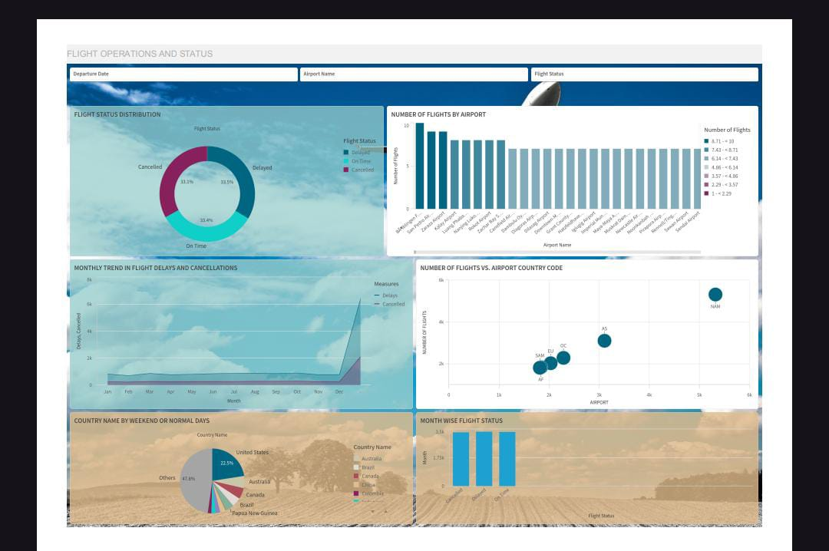

***DASHBOARD 3:TRENDS AND PATTERNS***

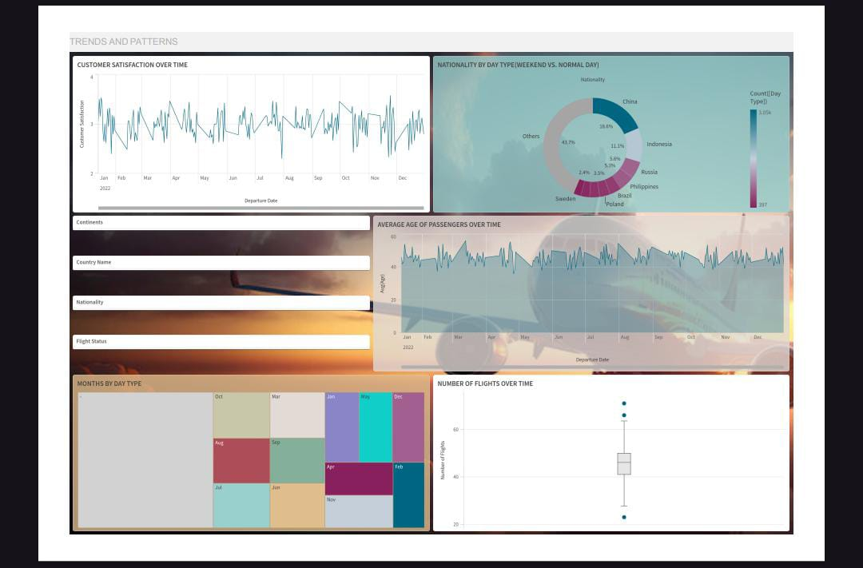

***7. REPORT***

Storytelling in Qlik is a feature that allows users to create guided narratives using their data insights, combining interactive visualizations with descriptive text to present a coherent and compelling analysis. This feature, known as Qlik Sense Stories, enables users to capture snapshots of visualizations from their dashboards and arrange them into a sequence, much like a presentation. Each snapshot can be annotated with text, images, and other media to provide context and highlight key insights.

Qlik storytelling enhances the communication of data-driven insights by structuring the information in a way that is easy to follow and understand, making it particularly useful for presentations to stakeholders who may not be familiar with the underlying data. Users can tell a complete story by linking multiple visualizations and insights together, showing how data evolves over time or across different dimensions. Additionally, Qlik Sense Stories are interactive; during the presentation, users can drill down into the data directly from the story, enabling a deeper exploration of the insights being presented.

***7.1 REPORT CREATION***

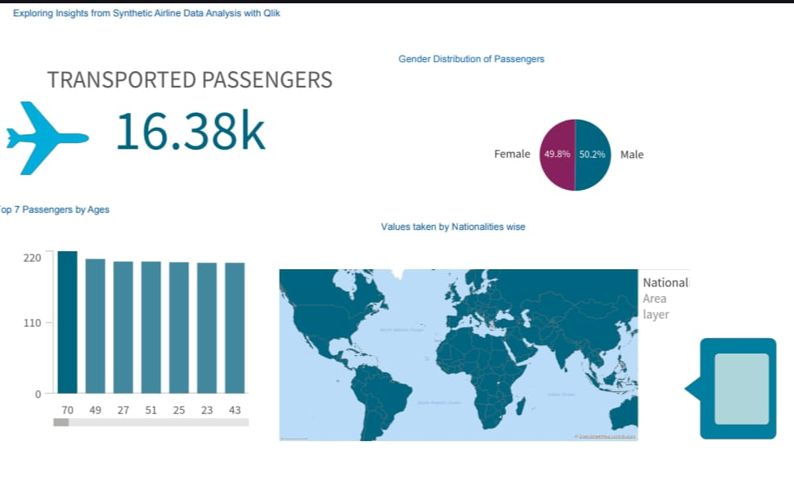

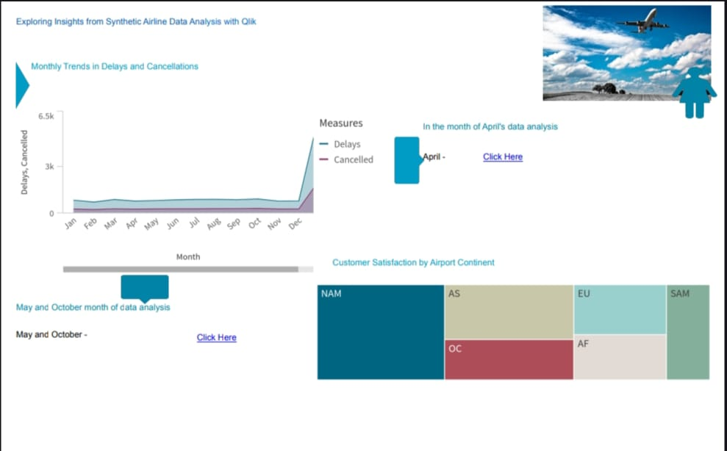

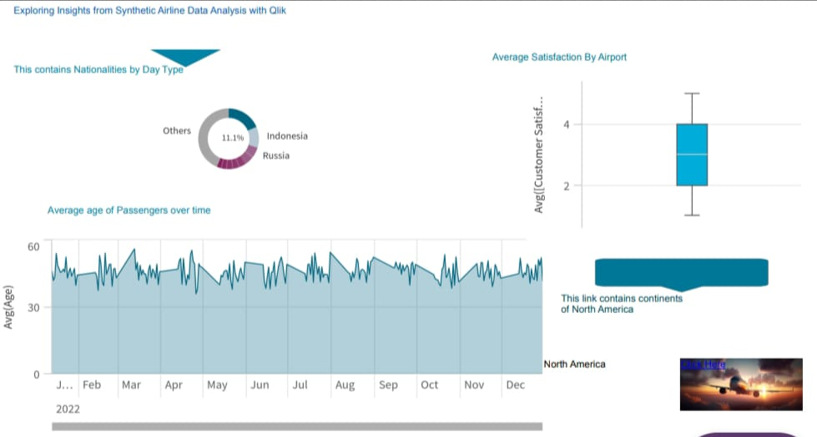

***8. PERFORMANCE TESTING***

Performance testing in Qlik is a critical process aimed at ensuring that Qlik applications, such as Qlik Sense or QlikView dashboards, operate efficiently and effectively under various conditions. The objective of performance testing is to evaluate how the Qlik application performs in terms of speed, responsiveness, and stability when subjected to different loads and usage scenarios. During performance testing, various aspects of the Qlik application are examined, including data loading times, dashboard rendering speeds, and query execution times.

***8.1 AMOUNT OF DATA RENDERED***

The amount of data rendered in Qlik refers to the volume of data that Qlik applications, such as Qlik Sense or QlikView, can process, visualize, and interact with effectively in real-time. This encompasses all the data loaded into the application from various sources, transformed, and then displayed through dashboards and reports. Qlik's associative data model is designed to handle large datasets efficiently, allowing users to explore vast amounts of data without compromising on performance.

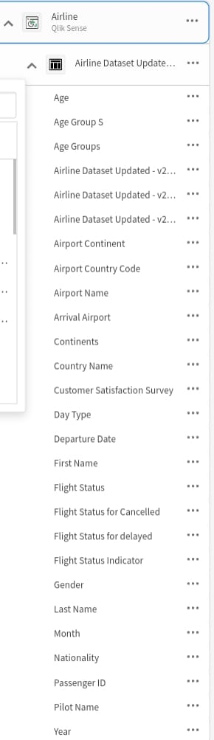

***8.2 UTILIZATION OF DATA FILTERS***

The utilization of filters in Qlik is a fundamental feature that enhances data exploration and analysis by allowing users to dynamically narrow down and focus on specific subsets of data. Filters enable users to apply various criteria to their datasets, such as date ranges, geographic locations, product categories, or any other relevant dimensions, to isolate and analyze the information that is most pertinent to their needs. This interactive capability ensures that users can quickly drill down into the details, identify patterns, and gain deeper insights from their data.

In Qlik, filters are applied through user-friendly interfaces such as selection panes, drop-down menus, and interactive visualizations. When a filter is applied, the entire dashboard updates in real-time to reflect the selected criteria, showcasing only the relevant data points. This instant feedback loop is powered by Qlik’s associative data model, which efficiently processes and displays the filtered data without requiring extensive reloading or processing.

**1.1 FEB FILTER**

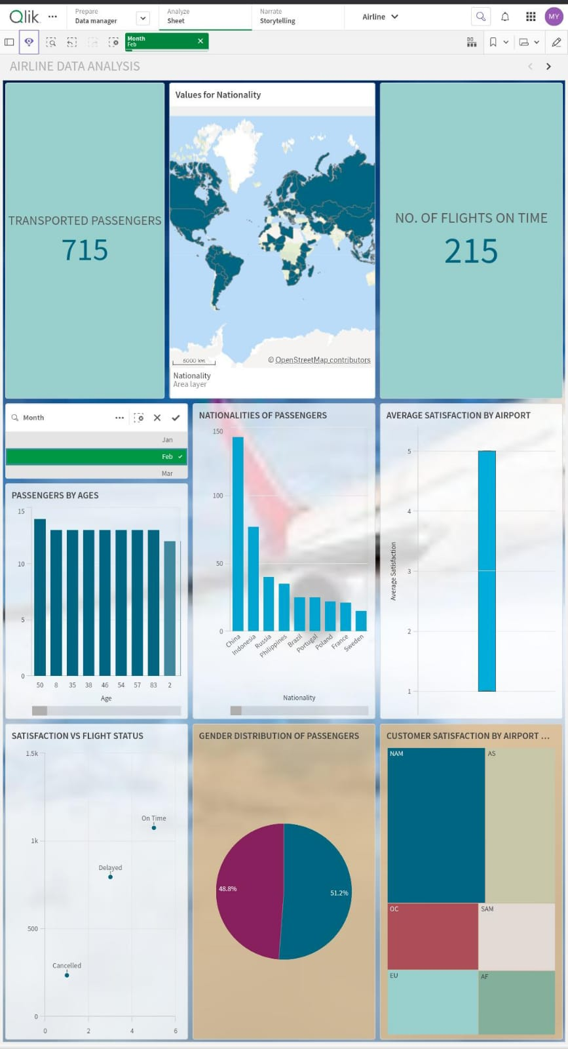

**1.2 MAY FILTER**

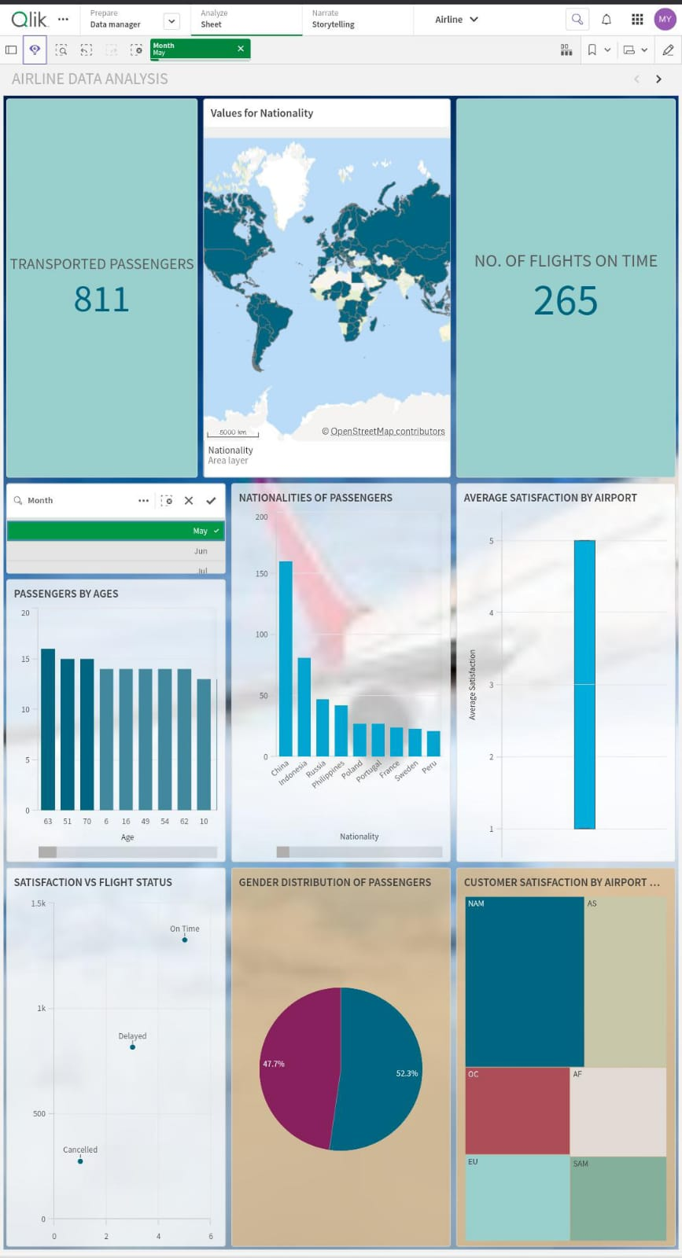

**1.3 NORTH AMERICA FILTER**

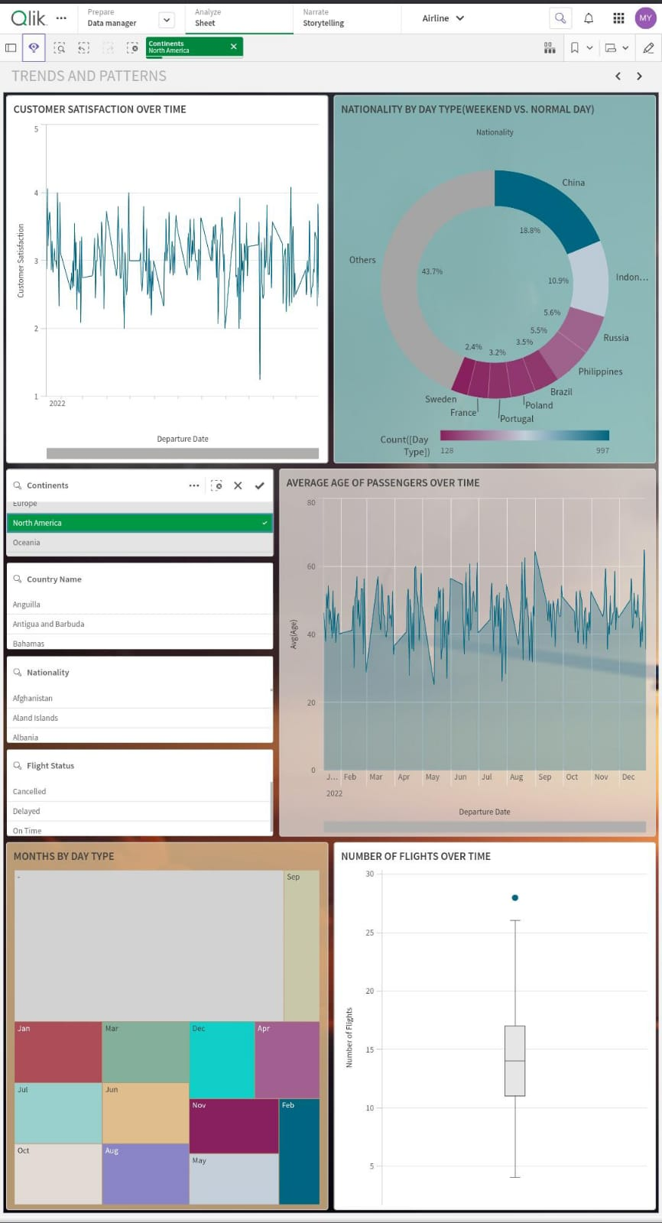

**1.4 OCENIA FILTER**

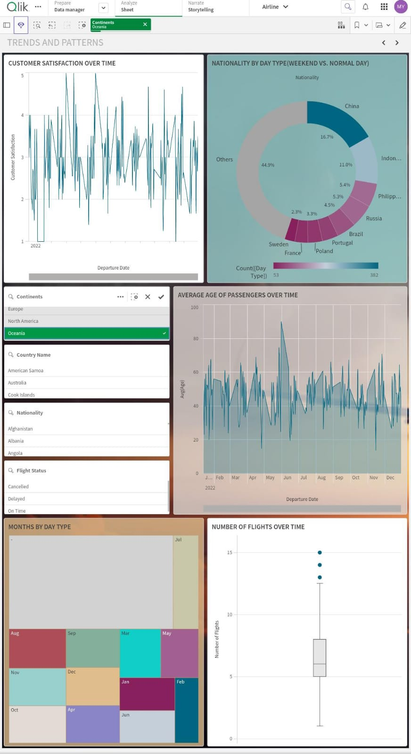

***9. CONCLUSION***

In conclusion, this project highlights the significant value of airline data in improving the efficiency and effectiveness of the aviation industry. By analyzing patterns in flight delays, cancellations, and on-time performance, we can develop strategies to optimize flight schedules, reduce disruptions, and enhance the overall travel experience for passengers. Utilizing advanced tools and predictive models, the project aims to proactively address issues, leading to better operational efficiency and higher customer satisfaction. Ultimately, by leveraging comprehensive data analysis and visualization, this project provides actionable insights that can drive meaningful improvements in airline operations and passenger experiences.